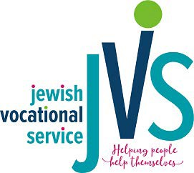
GUARANTOR APPLICATION FOR JEWISH STUDENT LOAN PROGRAM FOR SCHOOL YEAR: 2023-2024

Full Legal Name: Social Security #:

Permanent Address:

City:
State:
Zip Code:
County:

Length of time at this address:
If less than one year, please list previous address:

Previous Address:

City:
State:
Zip Code:
County:

Do you rent or own? (check one) Rent Own

Age: Date of Birth: Email Address:

Home Phone: Cell Phone:

Relationship to Applicant:

Employment Information:
Occupation:

Employer:

Length of time with this employer:

Annual Income:

I certify by my signature below that I have read the policies and procedures related to serving as a Guarantor for an interest-free student loan from Jewish Vocational Service (JVS) of MetroWest Inc. and agree to abide by those policies and procedures in full until the loan is repaid in its entirety.

Signature Printed Name Date

